Doctor of Philosophy

Xiaoming Li
“Design and Inference of Clinical Trials with Continuous Covariates”
Advisers: Jianhui Zhou & Feifang Hu (George Washington University)

Feiyang Niu
“Single-index Model with Varying Coefficients”
Adviser: Jianhui Zhou

Chenyi Pan
“Bayesian Tapering Test for Comparing two Spectral Densities with Application to EEG Data”
Adviser: Dan J. Spitzner

Caitlin I. Steiner
“Statistical Modeling of Brain to Muscle Stimulus-Response, Utilizing Transcranial Magnetic Stimulation (TMS)”
Adviser: Daniel M. Keenan

Master of Science
2015-2016
Yankun Chen Zhuowei Tang
Yucheng Chen Huiwen Tao
Heather Cook Truc Ngan Thi Tran
Boyang Dai Xinya Wang
Lin Han Zhengyi Wang
Young-Jun Kweon Zhengzhe Wang
Jiali Ling Ziyun Wang
Nina Liu Lauren Anne Williams
Xiaoshan Liu Minghui Wu
Yue Liu Bo Yang
Yutong Liu Megan Alexandra Yetman
Zhangzhang Liu Yue Yuan
Ziyi Liu Wenlu Zhang
Xingyu Ma Xueting Zhao
Karen Deanna Huang Pan Hui Zhou
Michael Salerno Zijun Zhou
Ryan Benjamin Saunders Yicong Zhu


Diploma Ceremonies
May 21, 2016
Welcome & Opening Remarks – Karen Kafadar, Chair
Awarding of Graduate Degrees in Statistics
Awarding of Undergraduate Degrees
       

   
Faculty Members Department of Statistics
Jessica Curran
Chao Du
Jeffrey J. Holt, Director of Undergraduate Studies Karen Kafadar , Chair
Daniel M. Keenan
Gretchen Martinet
Minh Pham
Dan J. Spitzner, Director of Graduate Studies
Amber Tomas
Yong Ming Jeffrey Woo
Tingting Zhang
Jianhui Zhou

Department of Statistics
University of Virginia

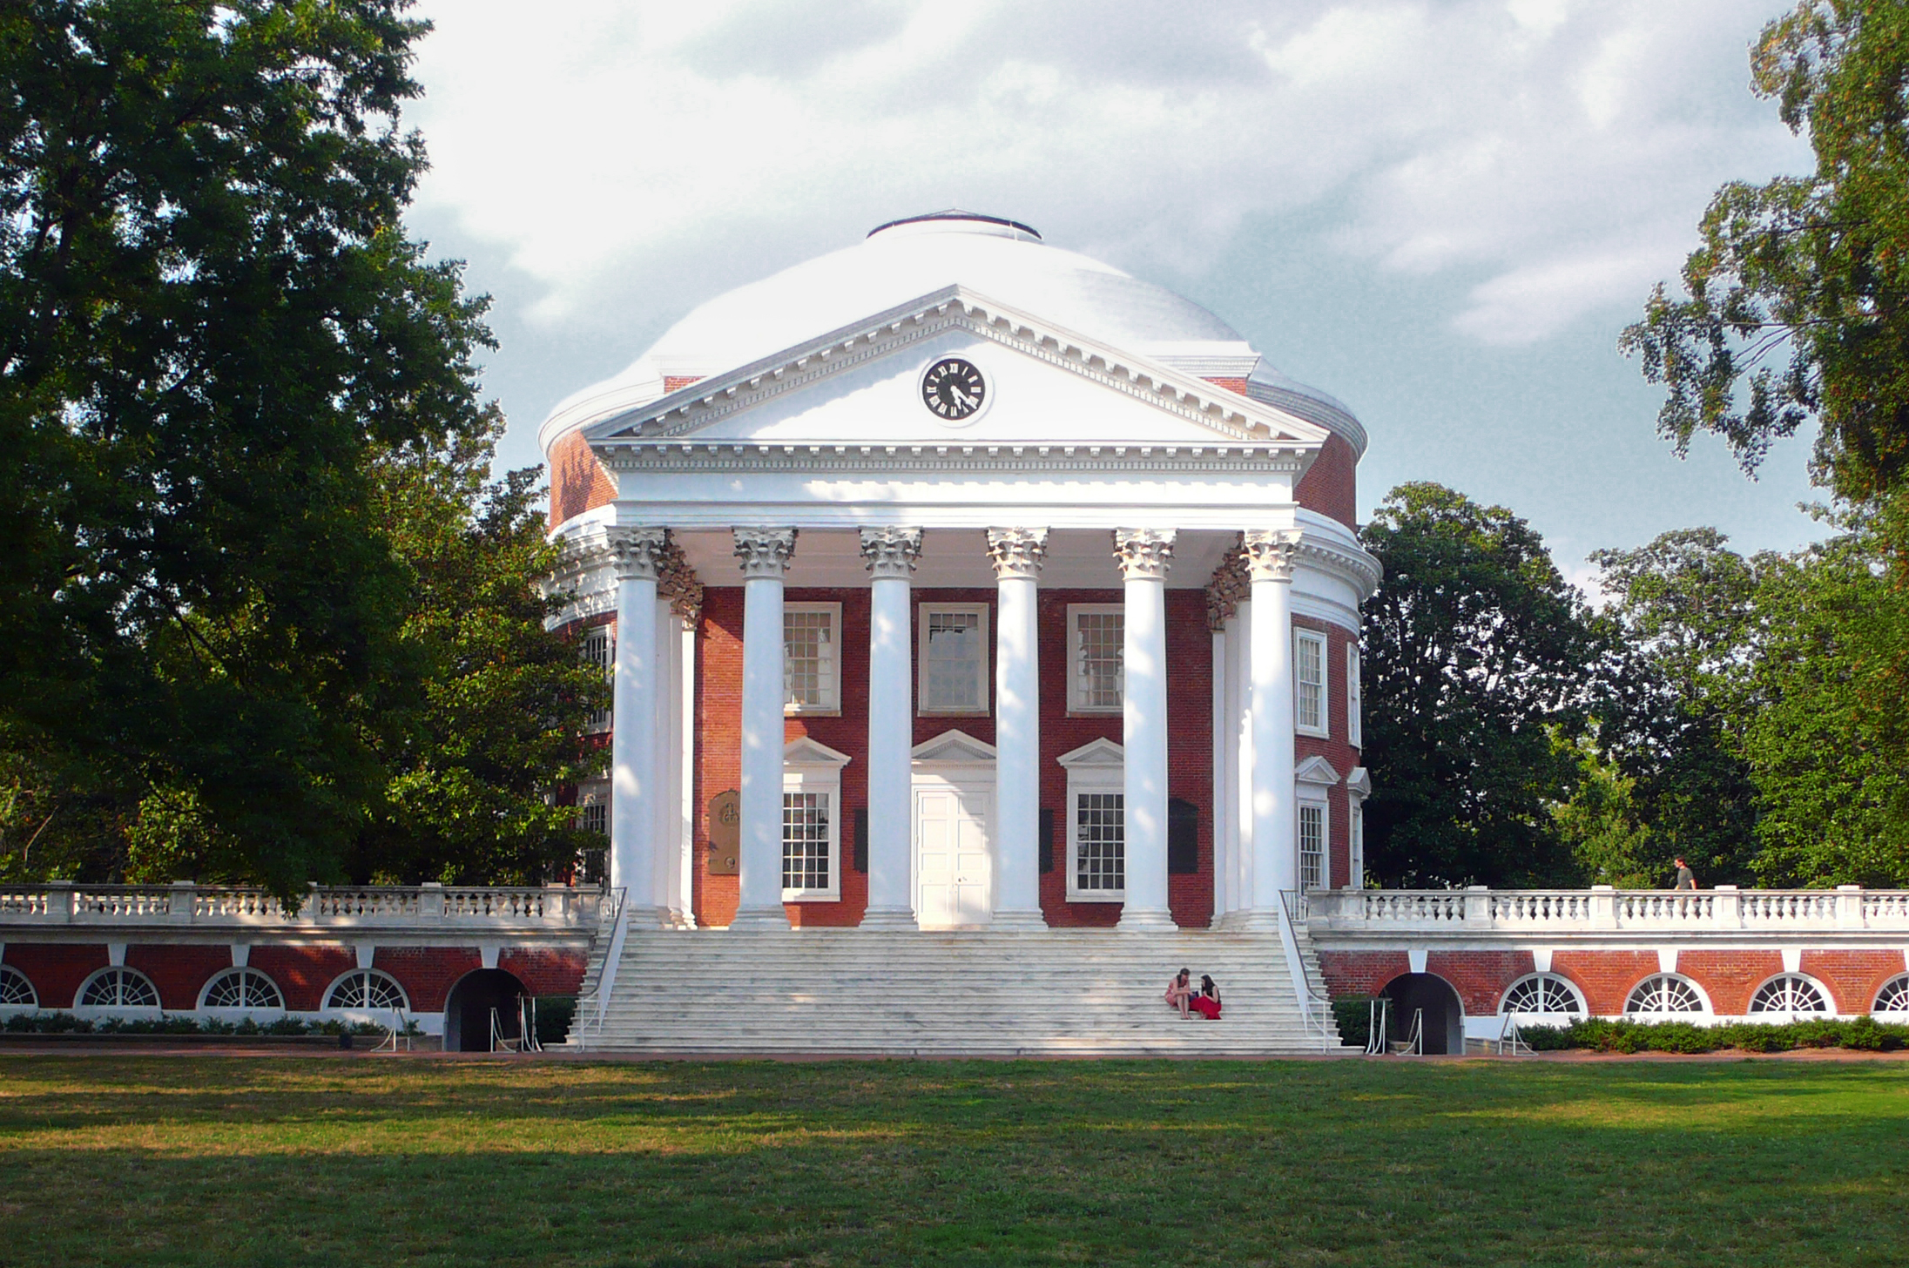

Diploma Ceremony
Ern Commons
May 21, 2016

Bachelor of Arts - 2016
Shubh Anand
Christopher Sungjin Bark
Adriel Joy Barrett-Johnson
Joseph Dacosta Albert Barrow
Emily Ann Bresnan
Lingfeng Cao
John Mayes Carpenter
Jessica Caroline Cederquist
Deepa Hazzarapu Chaganty
Maxwell Haoyun Chang
Linlin Chen
Xinyuan Chen
Jeong A. Cho
Yong Min Cho
Scott Philip Randall Clarke
Taylor Clayton Clarke
Alexander James Cohen
Thomas Wilson Coles
Patrick James Corbett
Matthew Alton Cott
Erin Rebekah Cronley
Heather Elizabeth Crosby
Chaz Adrian Daly
Michael Patrick Dettmar
Huiyang Ding
Mark Ryan Donehoo
Xiao Dong
Matthew Scott Dronfield
Nena Maria Evans
Dylan Louis Ferrer
Nathan Fogal
Lillian Gao
Christine Williams Harris
Syed Umer Hasan
Shan He
Yunchen Sylvia He
Stephen Andrew Heinzman
Michael Robert Herrmann
Andrew Mead Bass Hogue
Andrew Hua
Joanna Jeon
Sung-Jun Kang
Arthur Eli Kaplan
Nicolas Soungmin Kim
Soyun Kim
Hanhee Lee
Jimin Lee
Daniel Grant Lewis
Baijie Li
Kangkang Li
Yingying Li
Zhehao Li
Chuying Liu
Hongfan Liu
Zimeng Liu
Anna Rene Lockwood
Leonard Thomas Marshall
Amanda Lina McDermott
David Christopher McQuillen
Chetan Mishra
Mary Jacqueline Morrogh
Madison Murphy Mulvey
Ashwin Narayanan
Bachelor of Arts
Siobhan Nicolette Perks
Christian Martus Porter
Graham Charles Rockwood
Alexander Rey Rodriguez
Nathan Alexander Scholl
Stephen Thomas Scipione
Augustus Peter Shafron
Todd Duffy Shanosky
David Reeve Shore
Jennifer Elizabeth Sposato
Cody Alexander Stancil
Bernice Hui Yi Tay
Anisha Rajen Thanki
Florence Cheryl Thompson
Ercan Ucak
Sarah Kellogg Vaughan
Rong Wang
Emma Clair Ward
Margaret Xiaofen West
Frank Shawn Woodling
Austin John Wrenn
Arthur Naijun Wu
Xiyuan Wu
Zachary Austin Yates
Hyeyeon Yoon

